**Laboratory Work 11**

**HTML basic tags**

**Heading Tags**

Any document starts with a heading. You can use different sizes for your headings. HTML also has six levels of headings, which use the elements <h1>, <h2>, <h3>, <h4>, <h5>, and <h6>. While displaying any heading, browser adds one line before and one line after that heading.

Example

|  |  |
| --- | --- |
| **HTML code** | **Output** |
|  |  |

**Paragraph Tag**

The <p> tag offers a way to structure your text into different paragraphs. Each paragraph of text should go in between an opening <p> and a closing </p> tag as shown below in the example:

Example

|  |  |
| --- | --- |
| **HTML code** | **Output** |
|  |  |

**Line Break Tag**

Whenever you use the <br /> element, anything following it starts from the next line. This tag is an example of an empty element, where you do not need opening and closing tags, as there is nothing to go in between them.

Example

|  |  |
| --- | --- |
| **HTML code** | **Output** |
|  |  |

**Centering Content**

You can use <center> tag to put any content in the center of the page or any table cell.

Example

|  |  |
| --- | --- |
| **HTML code** | **Output** |
|  |  |

**Horizontal Lines**

Horizontal lines are used to visually break-up sections of a document. The <hr> tag creates a line from the current position in the document to the right margin and breaks the line accordingly.

For example, you may want to give a line between two paragraphs as in the given example below:

Example

|  |  |
| --- | --- |
| **HTML code** | **Output** |
|  |  |

**Preserve Formatting**

Sometimes, you want your text to follow the exact format of how it is written in the HTML document. In these cases, you can use the preformatted tag <pre>.

Any text between the opening <pre> tag and the closing </pre> tag will preserve the formatting of the source document.

Example

|  |  |
| --- | --- |
| **HTML code** | **Output** |
|  |  |

Try using the same code without keeping it inside <pre>...</pre> tags

**Bold Text**

Anything that appears within <b>...</b> element, is displayed in bold as shown below:

Example

|  |  |  |
| --- | --- | --- |
| **HTML code** | **Output** | |
|  | | The following word uses a **bold** typeface. |

**Italic Text**

Anything that appears within <i>...</i> element is displayed in italicized.

**Underlined Text**

Anything that appears within <u>...</u> element, is displayed with underline.

**Strike Text**

Anything that appears within <strike>...</strike> element is displayed with strikethrough, which is a thin line through the text.

**Superscript Text**

The content of a <sup>...</sup> element is written in superscript; the font size used is the same size as the characters surrounding it but is displayed half a character's height above the other characters.

|  |  |
| --- | --- |
| **HTML code** | **Output** |
| <!DOCTYPE html>  <html>  <head>  <title>Superscript Text Example</title>  </head>  <body>  <p>The following word uses a <sup>superscript</sup> typeface.</p>  </body>  </html> |  |

**Subscript Text**

The content of a <sub>...</sub> element is written in subscript; the font size used is the same as the characters surrounding it, but is displayed half a character's height beneath the other characters.

Example

|  |  |
| --- | --- |
| **HTML code** | **Output** |
| <!DOCTYPE html>  <html>  <head>  <title>Subscript Text Example</title>  </head>  <body>  <p>The following word uses a <sub>subscript</sub> typeface.</p>  </body>  </html> |  |

|  |  |
| --- | --- |
| **HTML code** | **Output** |
|  |  |

**Grouping Content**

The <div> and <span> elements allow you to group together several elements to create sections or subsections of a page.

For example, you might want to put all of the footnotes on a page within a <div> element to indicate that all of the elements within that <div> element relate to the footnotes. You might then attach a style to this <div> element so that they appear using a special set of style rules.

Example

|  |
| --- |
| **HTML code** |
| <!DOCTYPE html>  <html>  <head>  <title>Div Tag Example</title>  </head>  <body>  <div id="menu" align="middle" >  <a href="/index.htm">HOME</a>  <a href="/about/contact_us.htm">CONTACT</a>  <a href="/about/index.htm">ABOUT</a>  </div>    <div id="content" align="left" bgcolor="white">  <h5>Content Articles</h5>  <p>Actual content goes here.....</p>  </div>  </body>  </html> |

**Output:**

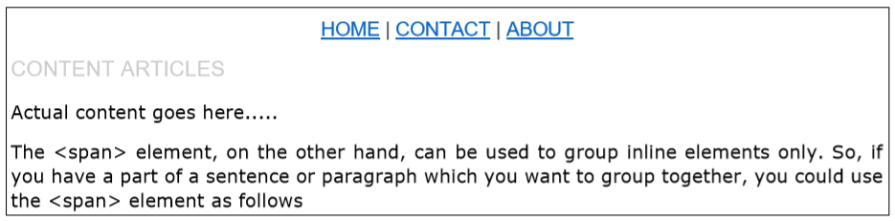

Other HTML tags

|  |  |  |
| --- | --- | --- |
| **HTML tag** | **Description** | **Example** |
| <a> | The <a> tag is used to provide the basic web link | <a href = "http://www.example.com"> link to example.com</a> |
| **<img>** | The img tag is used in to attach an image. | <img src=”../images/logo.png”alt=”This is just some picture” />  NOTE:   * the **src** attribute specifies the image URL * HTML5 also requires an **alt** attribute describing the image |
| <!-- --> | Comments tag | <img src=”../images/logo.png”alt=”This is just some picture” /> <!-- This just my comments --> |

**HTML characters entities**

|  |  |
| --- | --- |
| **character(s)** | **entity** |
| < > | &lt; &gt; |
| ™ © | &trade; &copy; |
| π δ Δ | &pi; &delta; &Delta; |
| " & | &quot; &amp; |

**Tasks**

**Checking HTML tags**

1. Open Notepad.
2. Name this document as *Examples* and Save it with *.html* extension. (*Examples.html* )
3. Write html code (above) in *Examples.html* and check all the HTML tags, which have been shown in this lab file.

NOTE: You don’t need to create html file for each tag, just include these tags to the first file (*Examples.html*).

**Creating a Personal HTML Webpage using Python**

1. Using Python create a new file and named it *AboutMe.html*
2. Create a Personal Webpage with the information about yourself by using all basics HTML tags, which described above in this file. The page must include the following information:
   1. Full name
   2. Photo
   3. Age
   4. Brief information about yourself
   5. Email
   6. Birth country
   7. Hobbies
   8. Study interests
   9. Knowledge of languages
   10. Programming/IT skills
3. Automatically open this file on a new tab.